**List of Products**

**‘List of all Products’ Page** – This page shows you a detailed list of registered type of products. Here, you will see the product type. You also have the option to edit or delete product information, see product details and enter new product details.

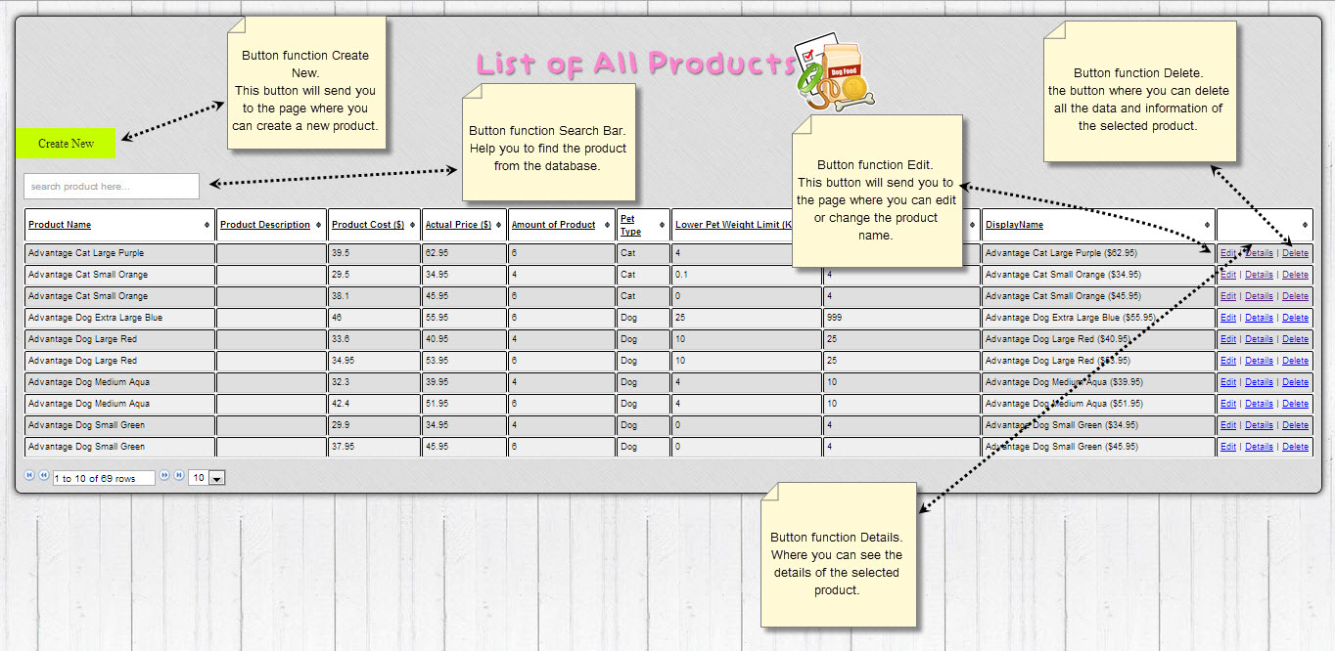

**‘Create New Product’ Page** – This page is where you enter type of your new product and also the details of the selected product.

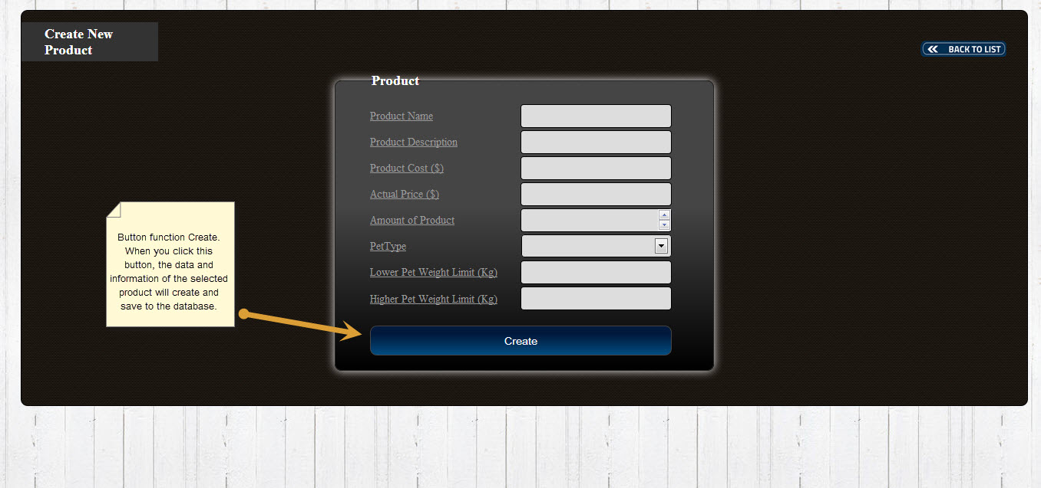

**‘Delete Pet Type’ Page-** This page is where you go to if you wish to delete product.

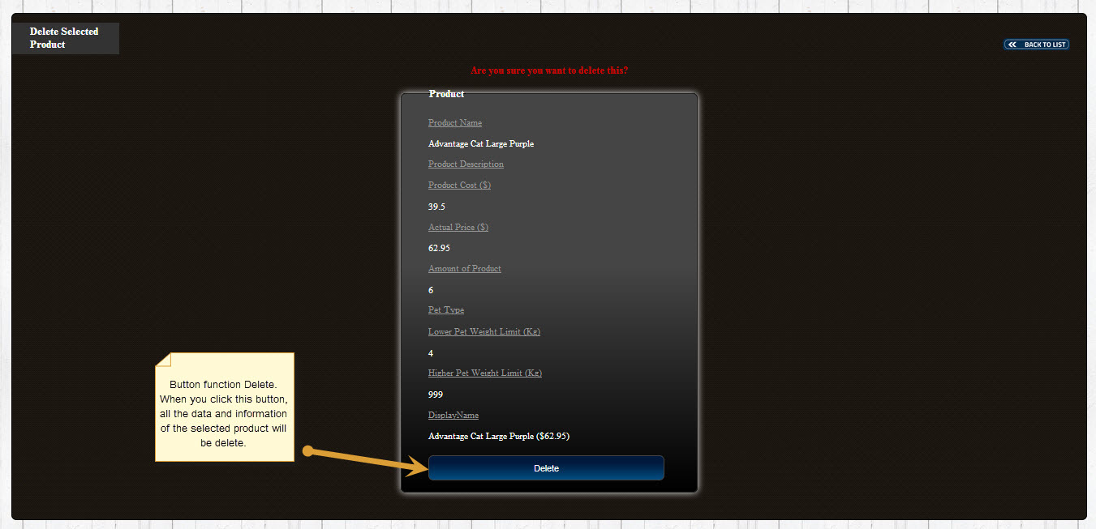

**‘Details of Product’ Page** – This page allows you to edit details of your product, such as its name, description, actual price, amount of product, pet type, lower pet weight limit and the higher pet weight limit.

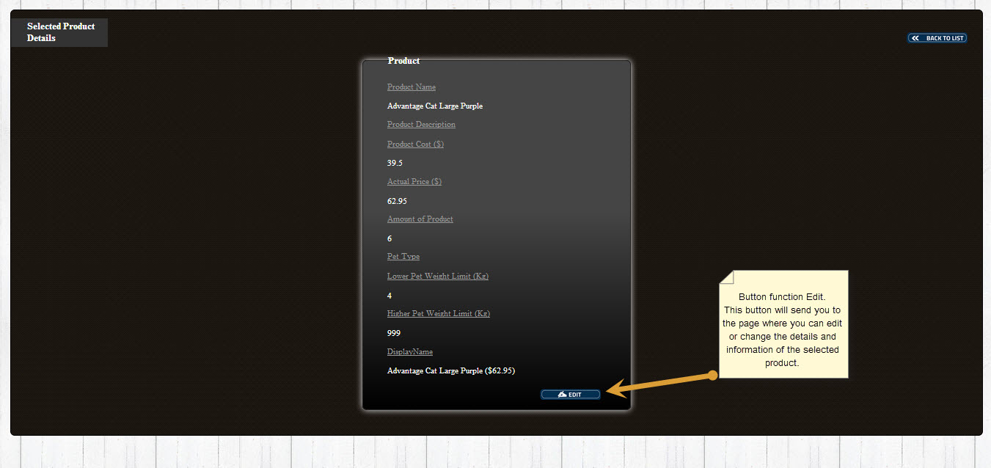

**‘Update Selected Product’ Page** – This page is where you can update product details if you wish to make changes to its name, description, actual price, amount of product, pet type, lower pet weight limit and the higher pet weight limit.

